CSC/SDS 109: Communicating with Data

# Customizing Tableau

The goal of today is to dive deeper into what you can do with Tableau. Find someone to work with and follow the walkthrough below. At the end is a prompt for you to explore some more on your own.

First, load the US-National-Parks_RecreationVisits_1979-2023.csv data into Tableau. It is available for download here: <https://www.responsible-datasets-in-context.com/posts/np-data/>.

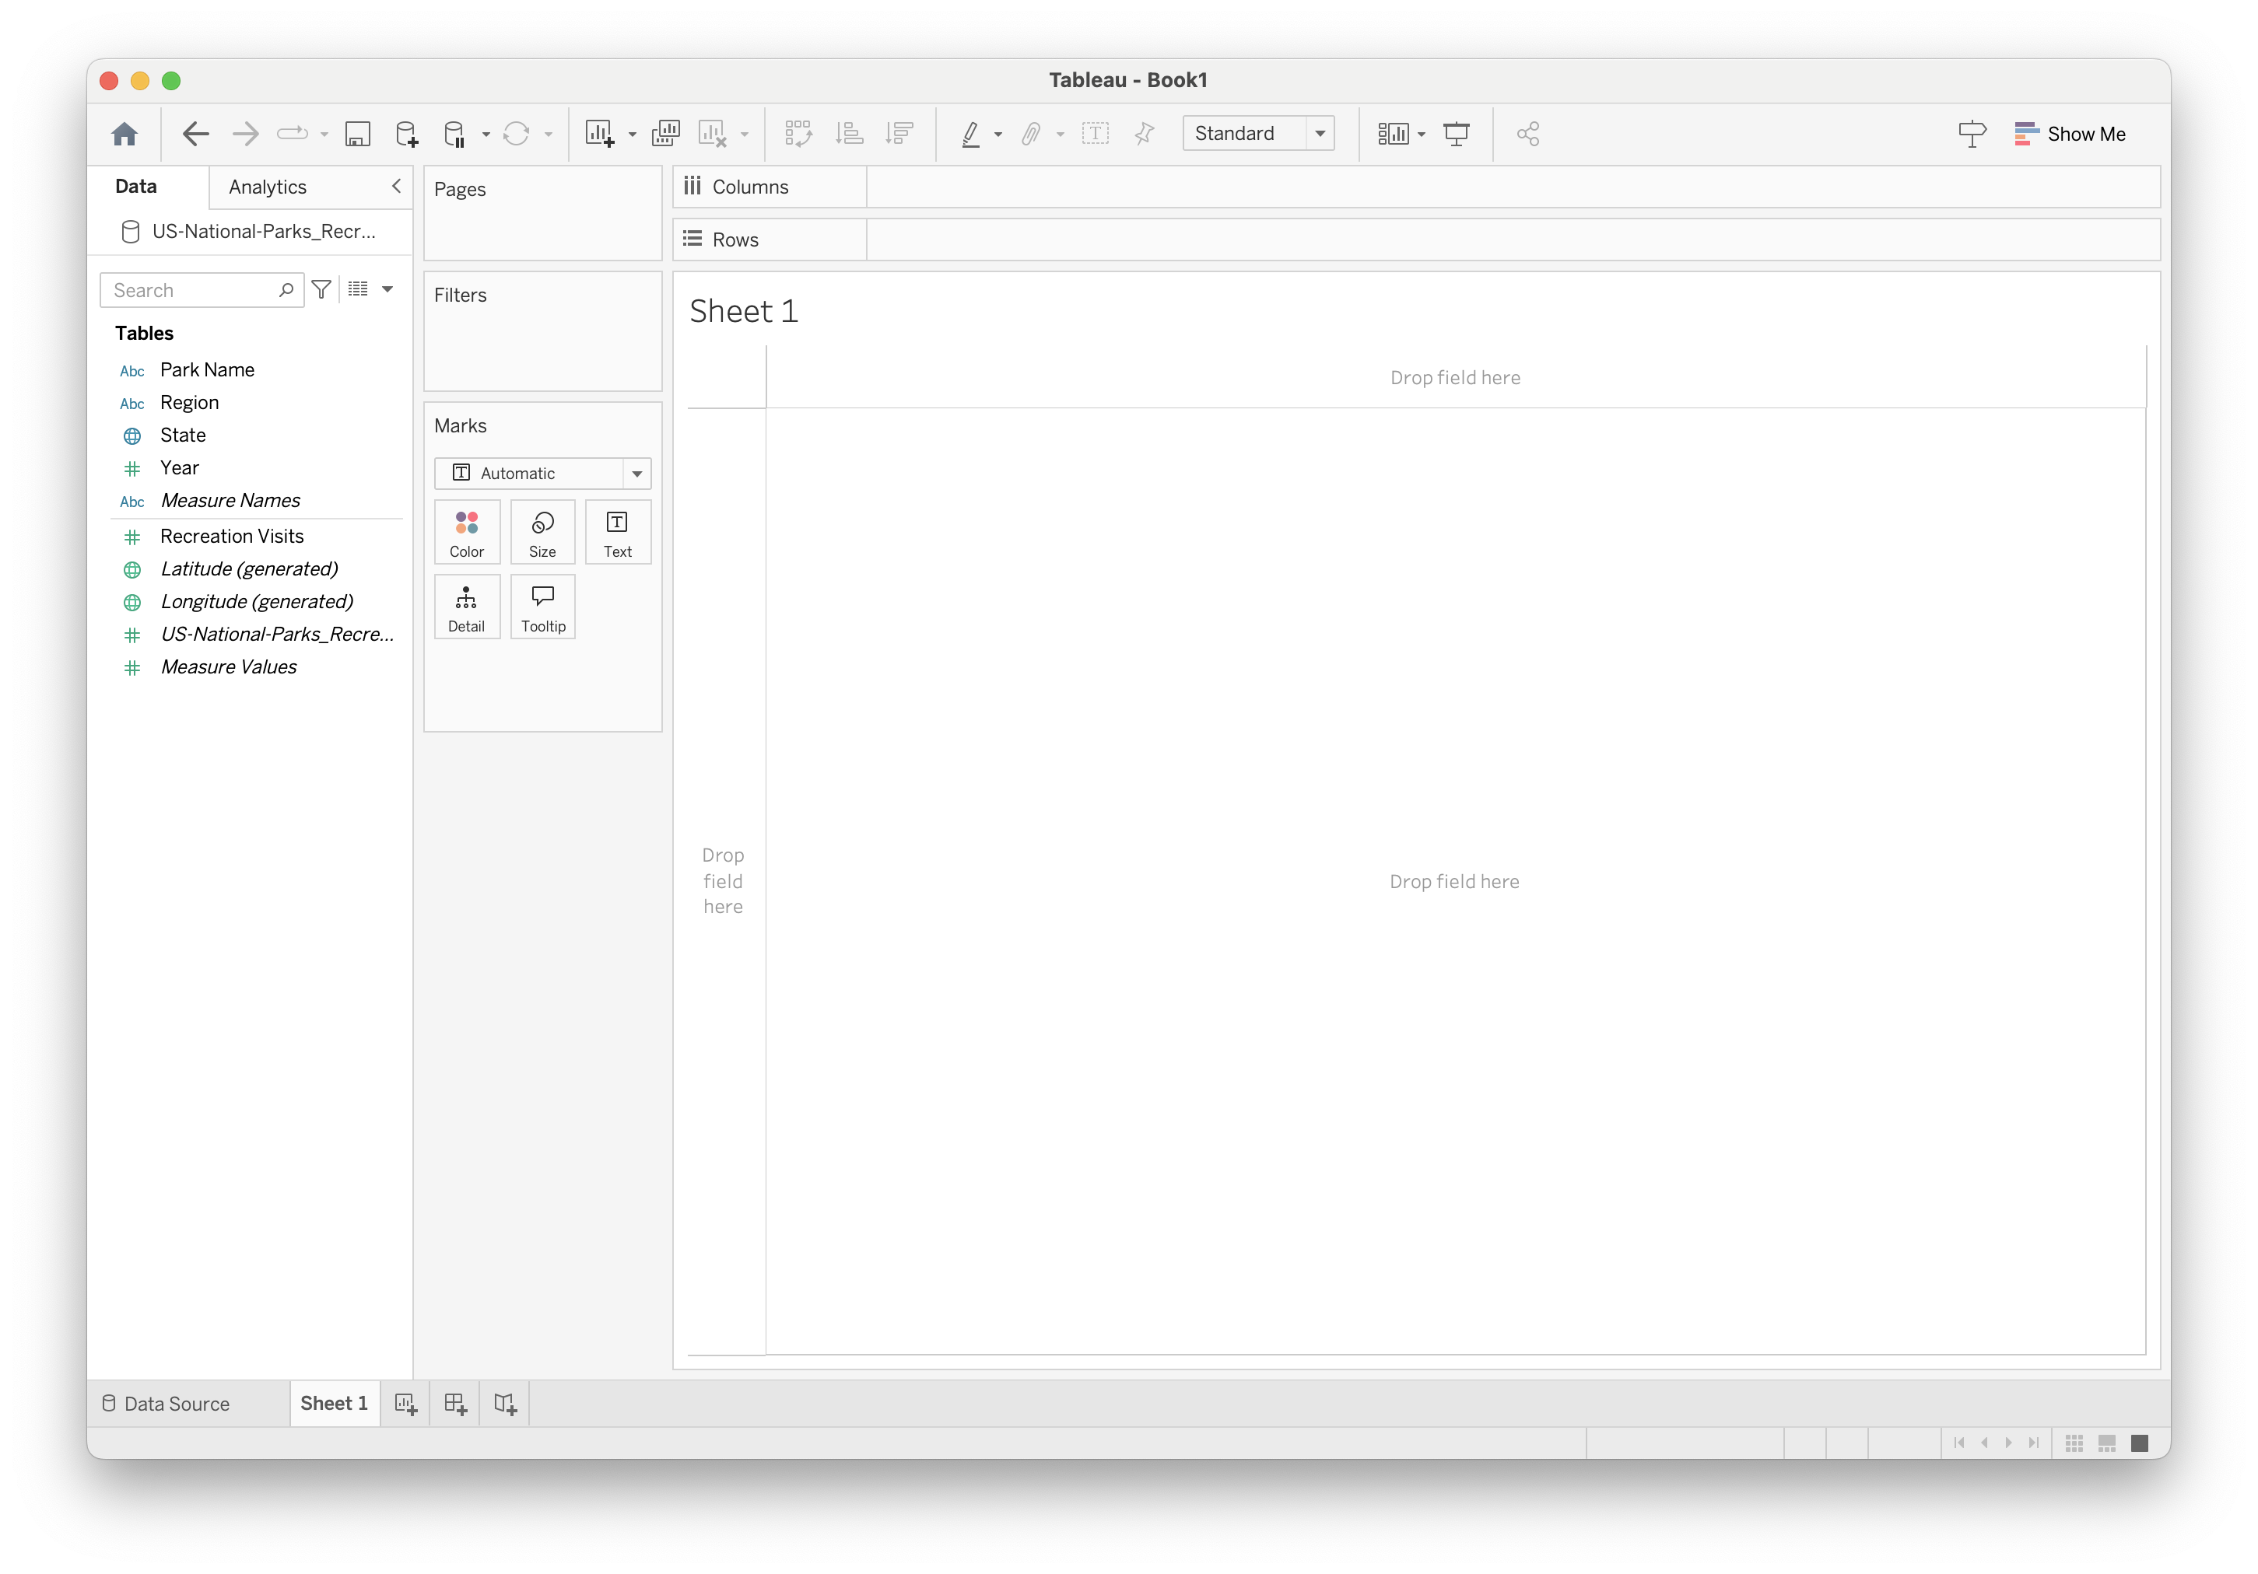

First, let’s take a look at visits over the years broken out by region: 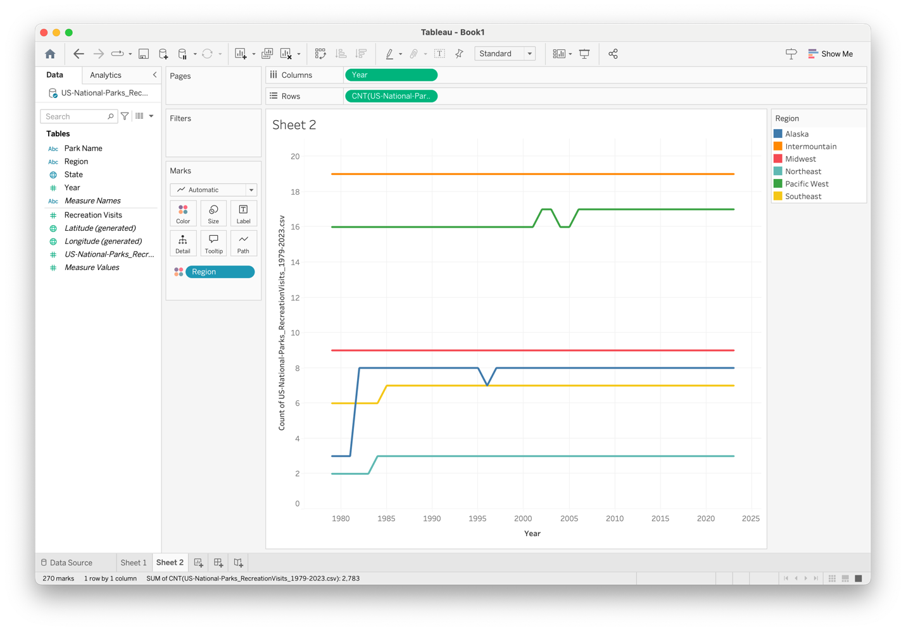

Let’s use a custom color palette. First, open Preferences.tps – you will need to right click and choose a text editor (I used Sublime).

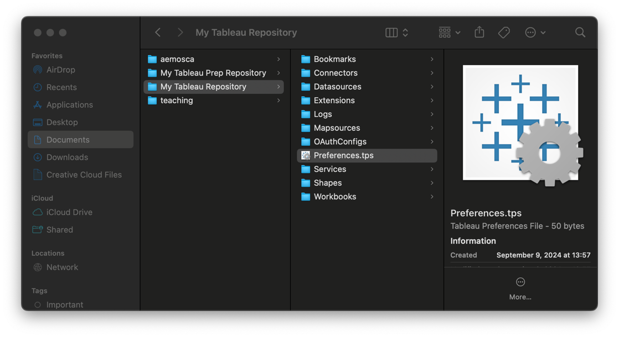

Preferences.tps will look like this:

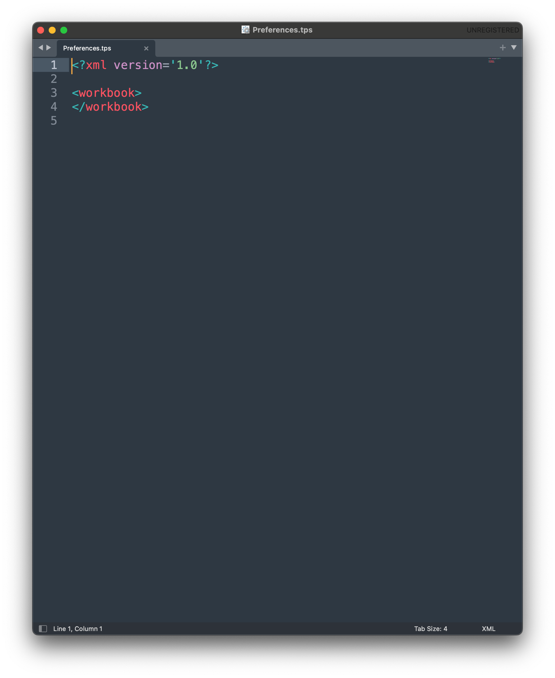

Between the <workbook> tags, add <preferences> tags:

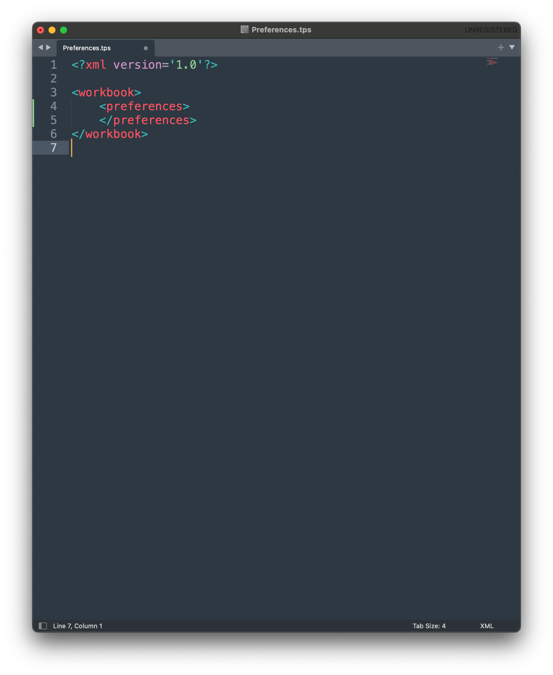

Now, between <preferences> tags you can add your custom color palettes. I’m going to add a few I got from ColorBrewer (<https://colorbrewer2.org/>).

A categorical palette is type = ‘regular’:

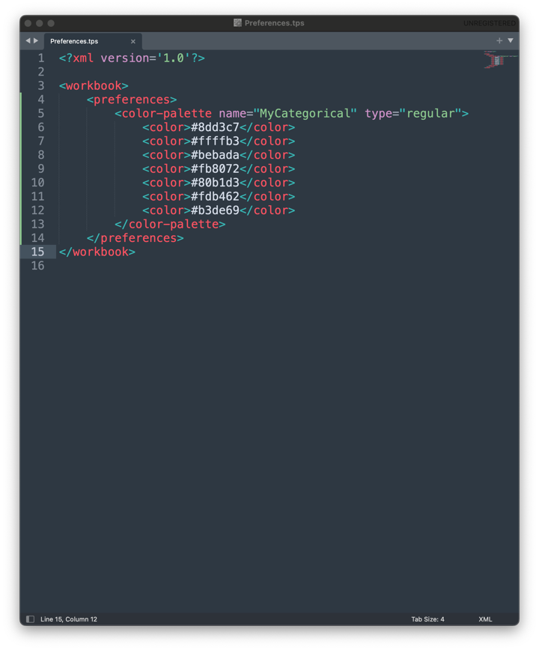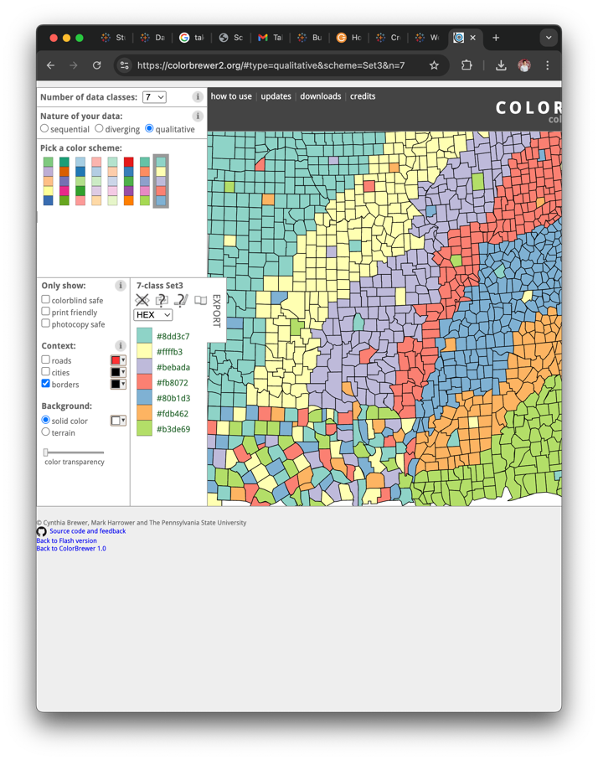

A sequential palette is type = ‘ordered-sequential’:

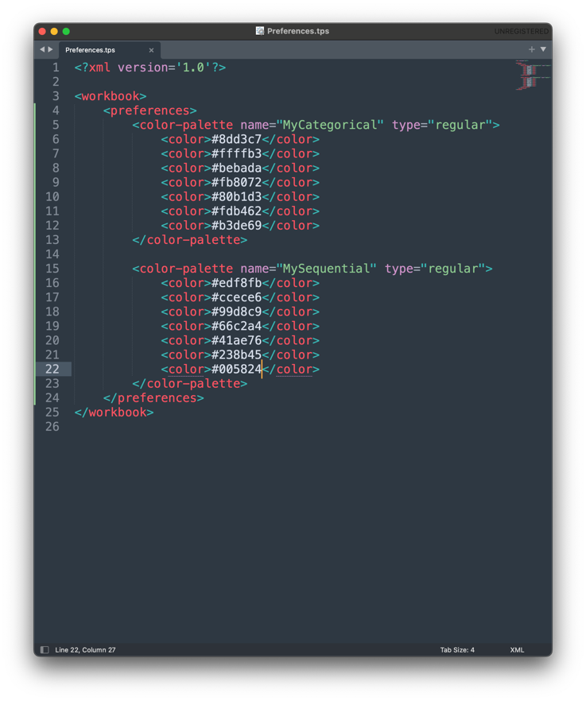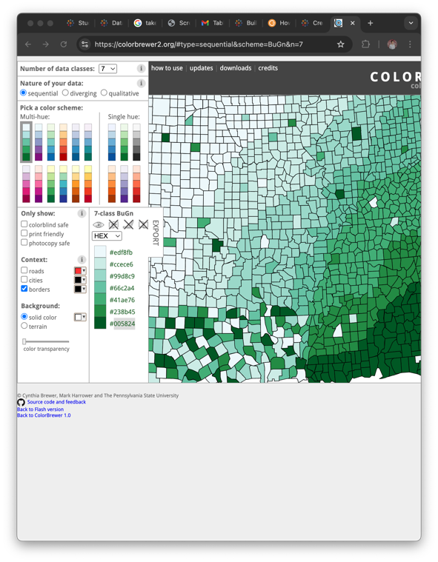

A diverging palette is type = ‘ordered-diverging’:

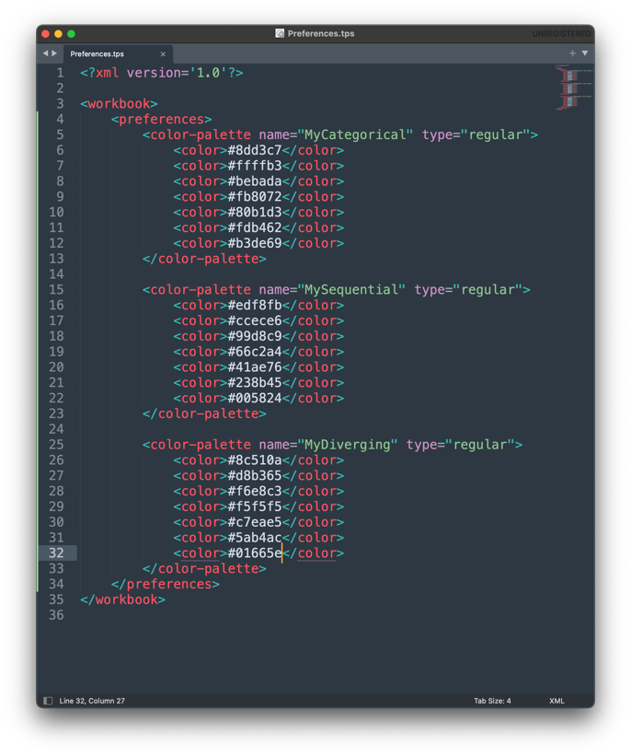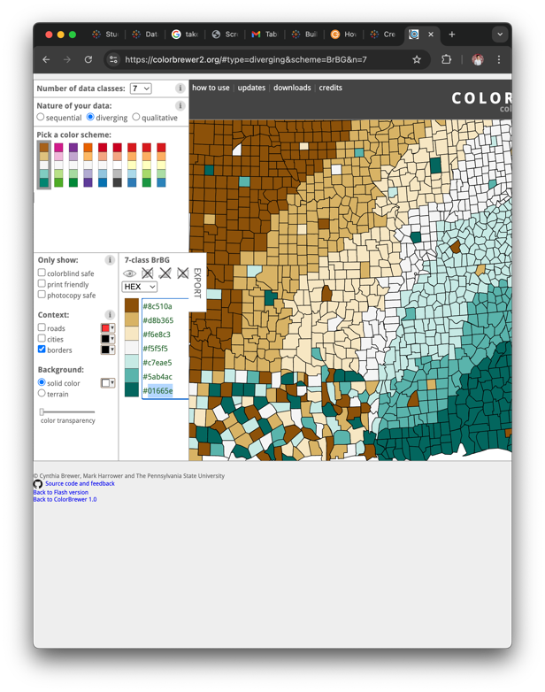

Save your file and then restart Tableau to see the changes:

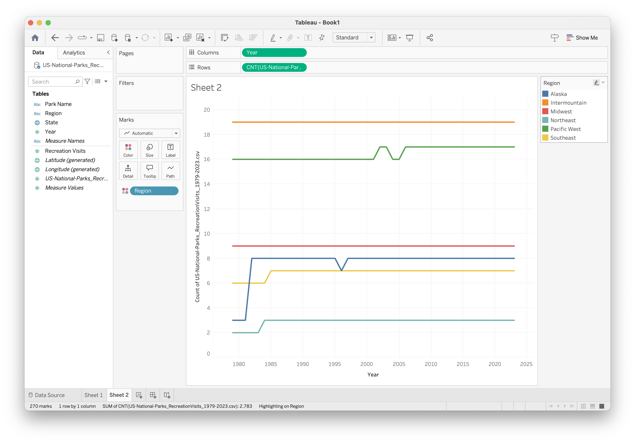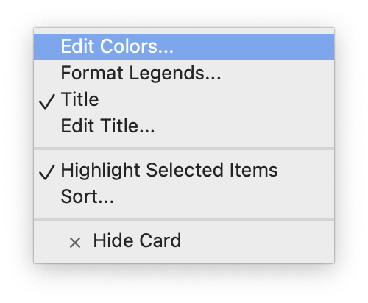

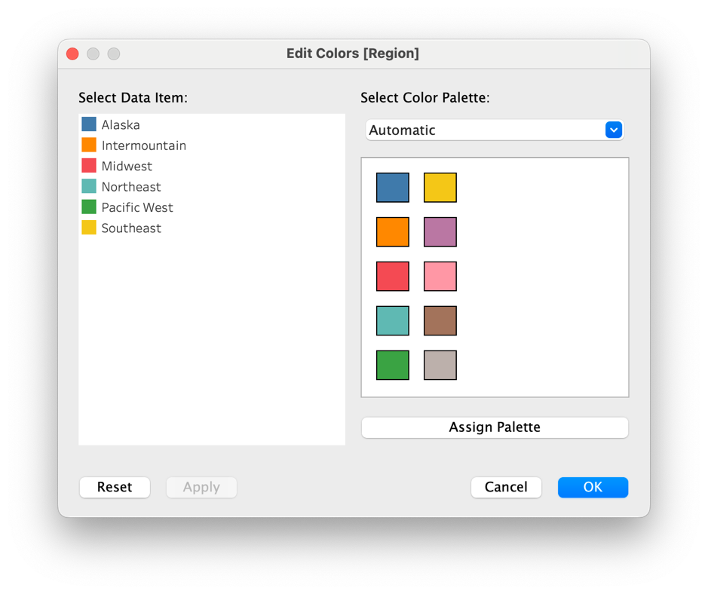

Look for your new palettes in the dropdown:

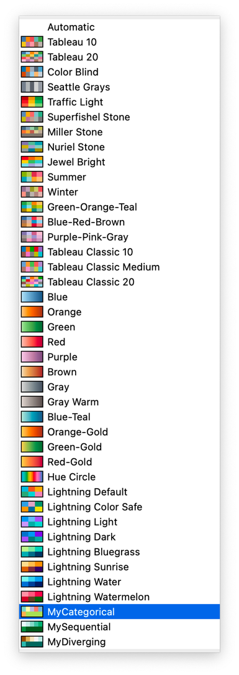

Select, and Assign Palette:

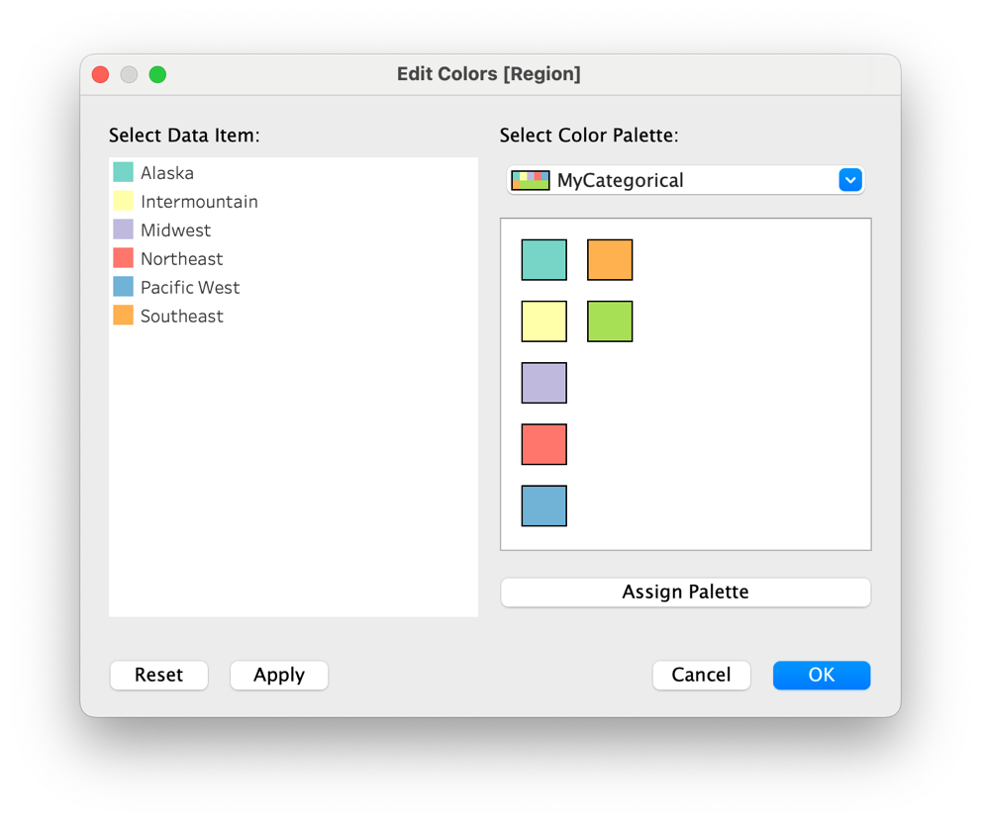

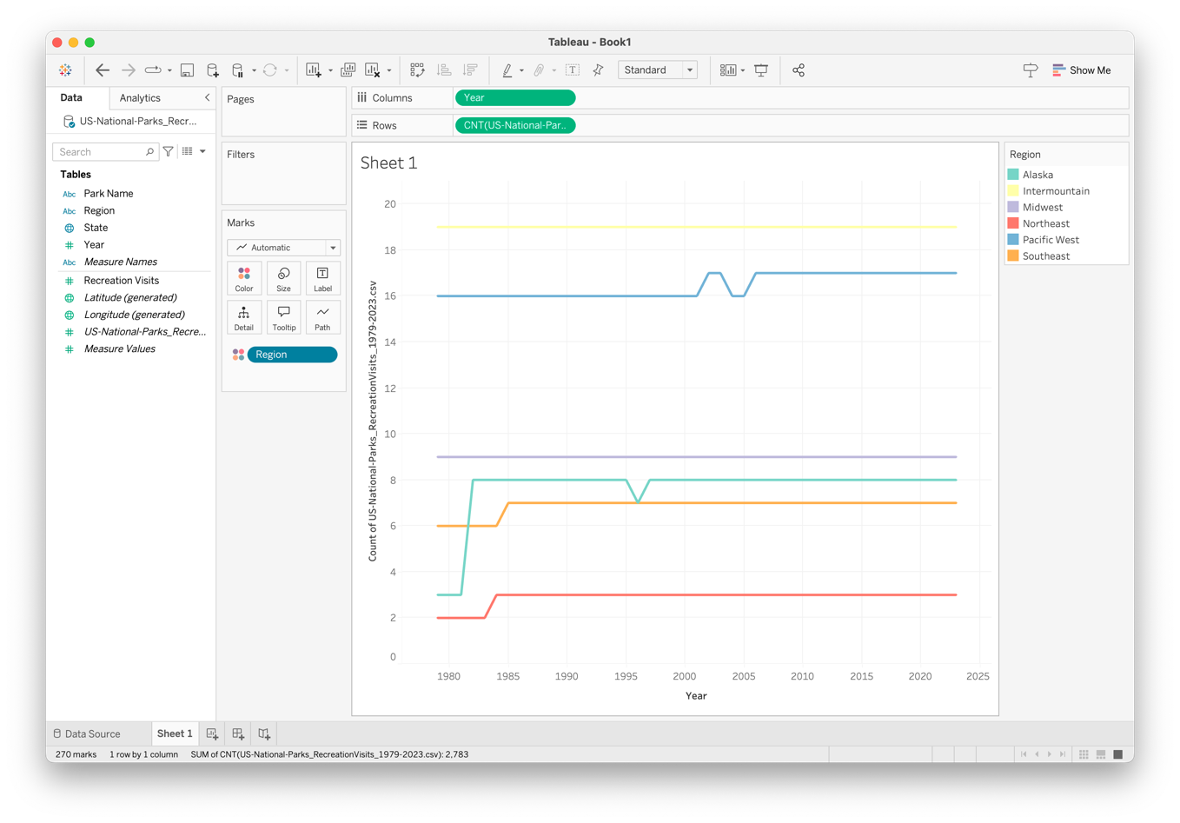

Great! Now, let’s look at Visits by Region:

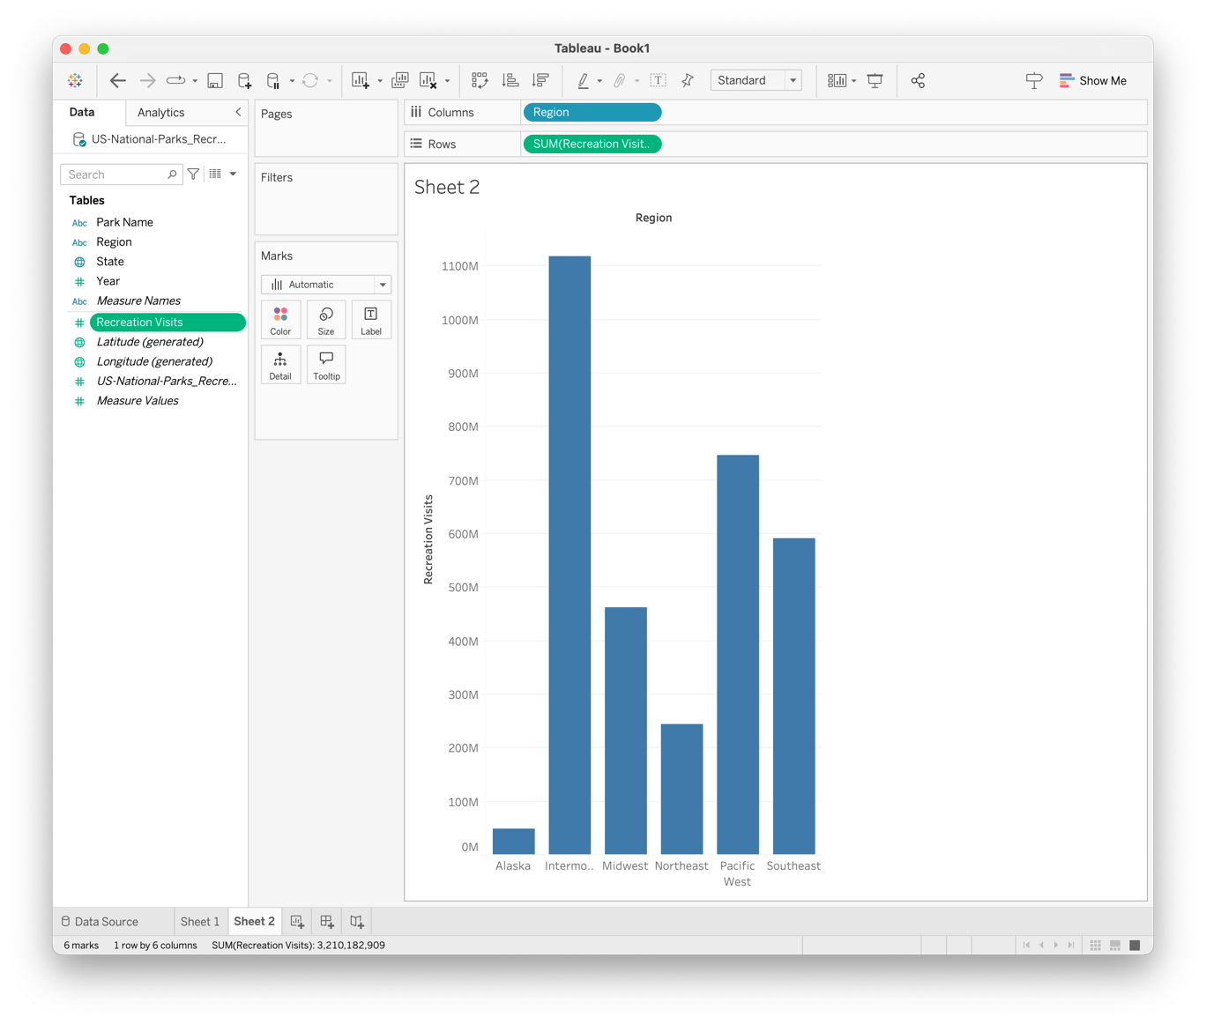

Hmm, the axis labels are difficult to read. Let’s fix that:

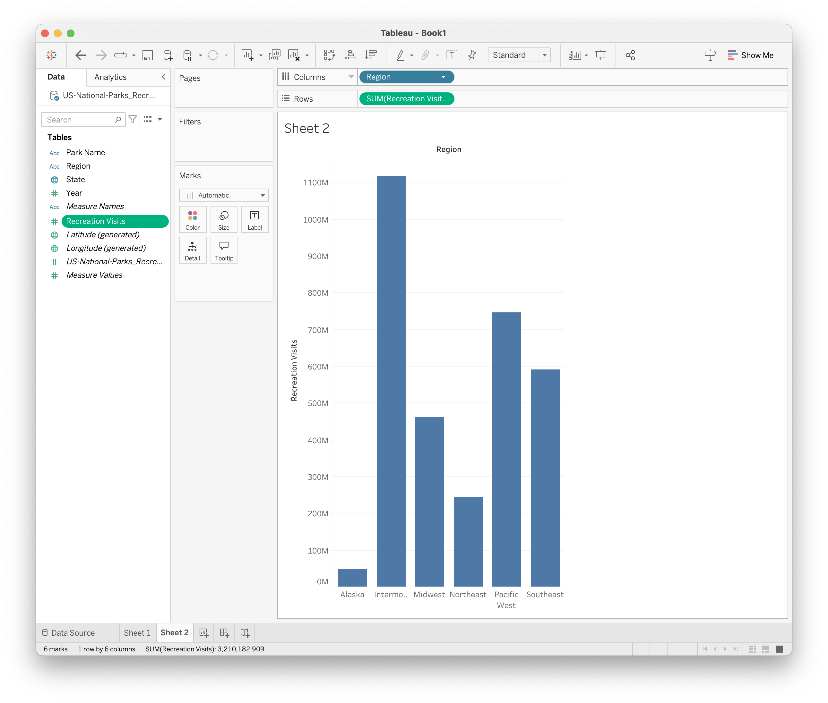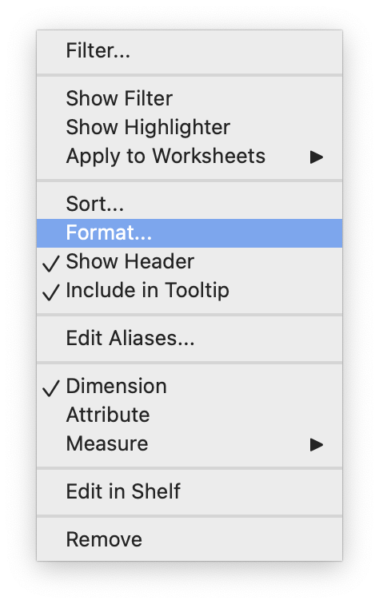

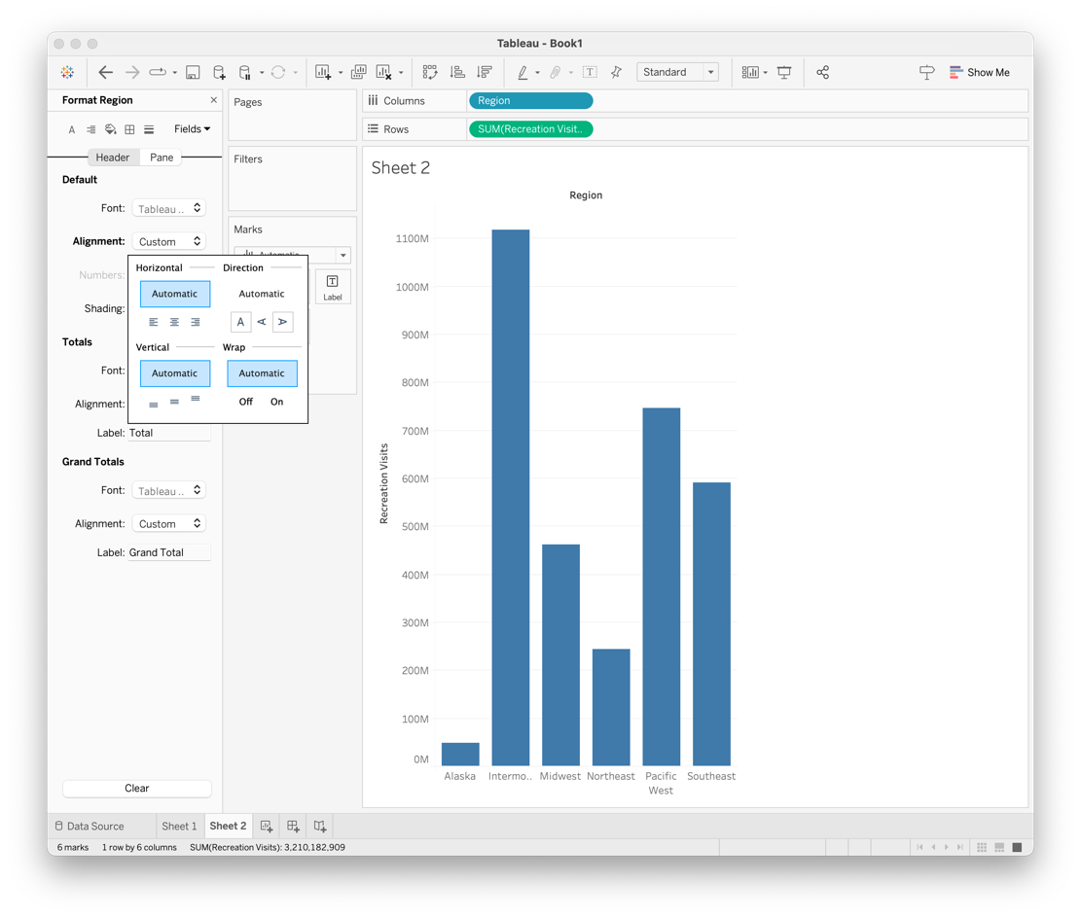

Much better:

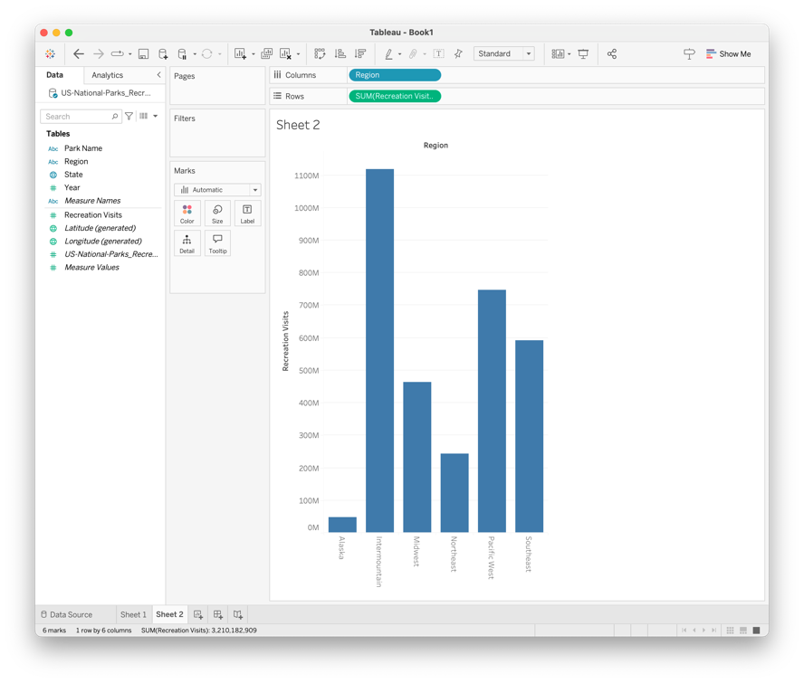

Finally, let’s look at the number of parks per region. Start like this:

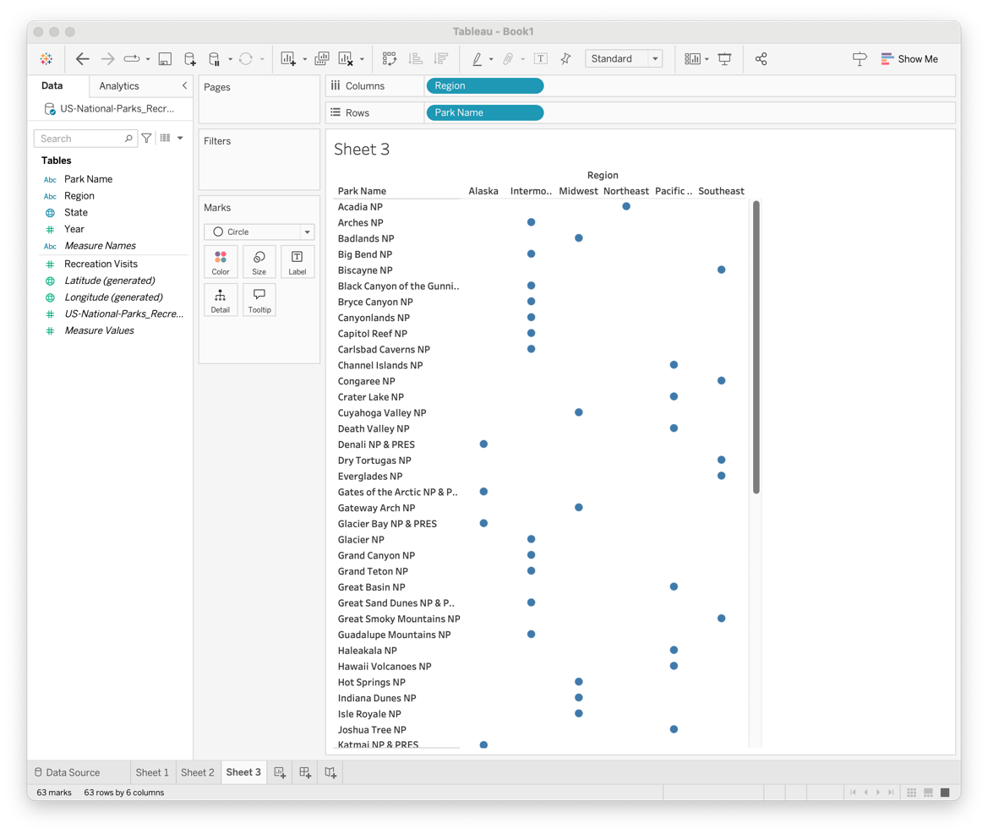

And edit Park Name to get a measure:

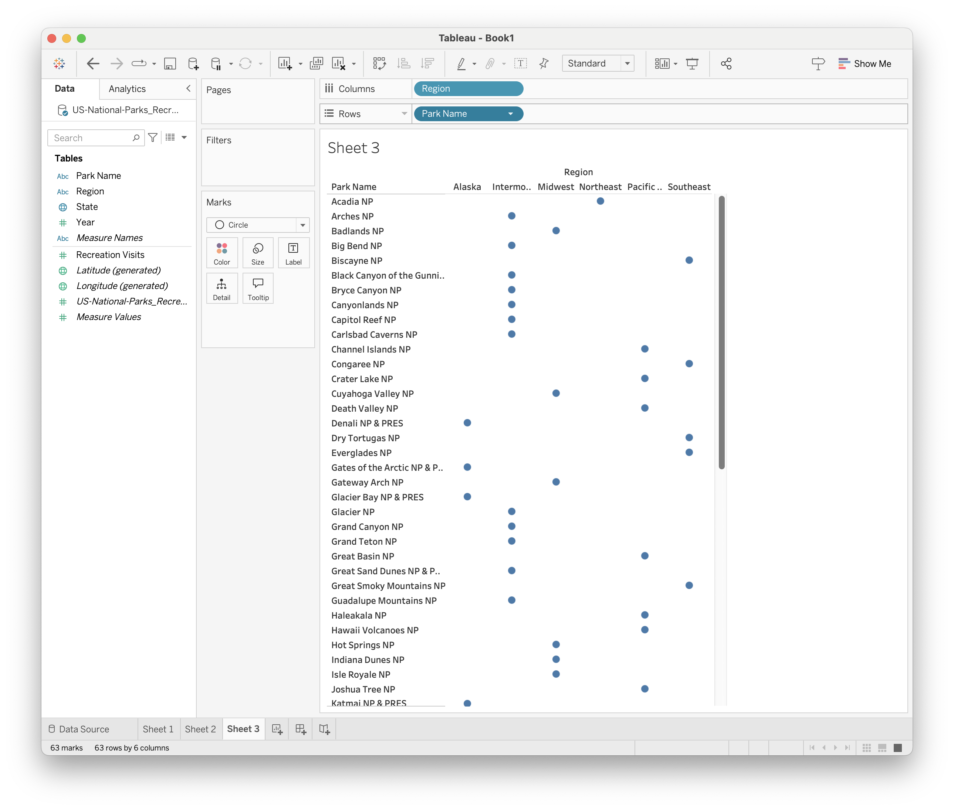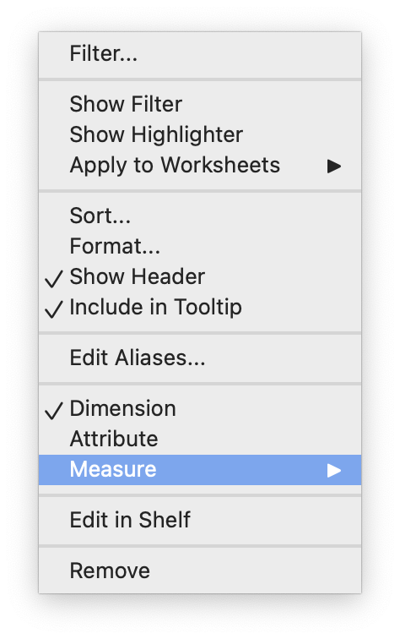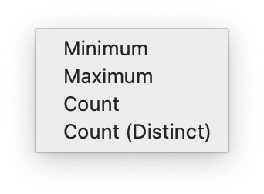

Like so:

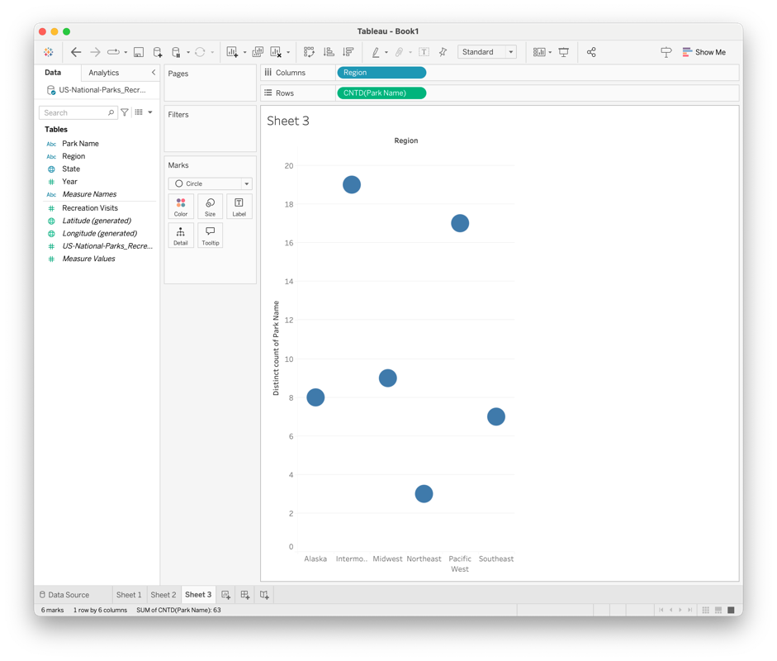

Now, let’s say we want some custom icons for each region. Go to the Marks area and select Shape instead of circle:

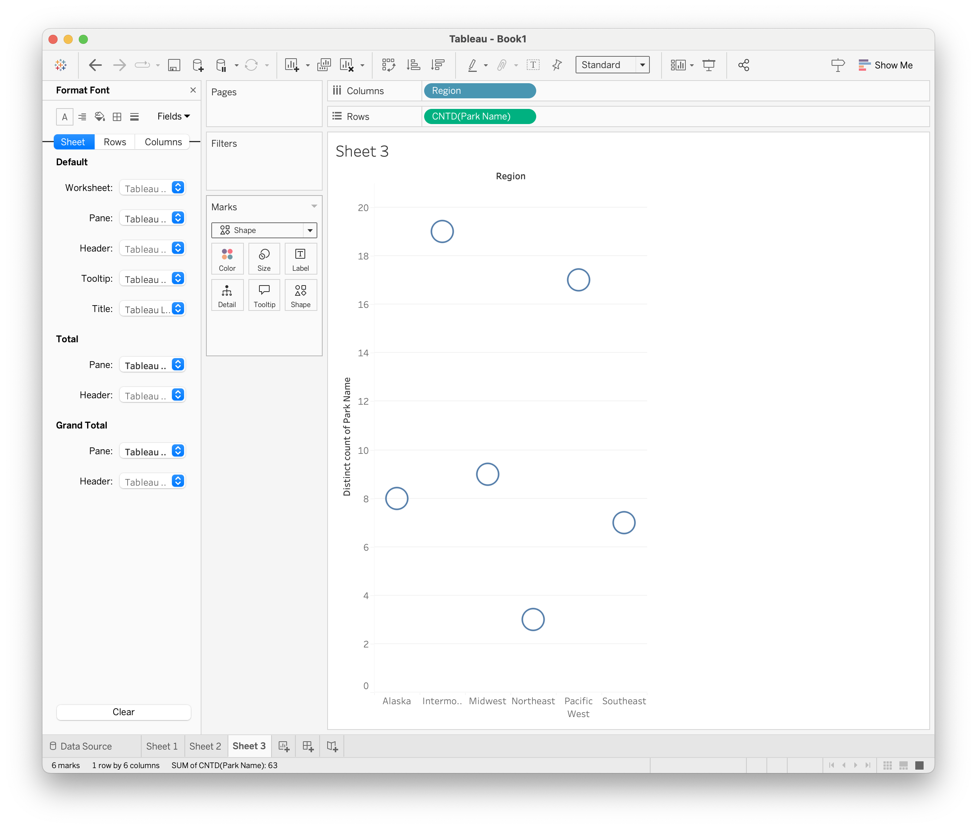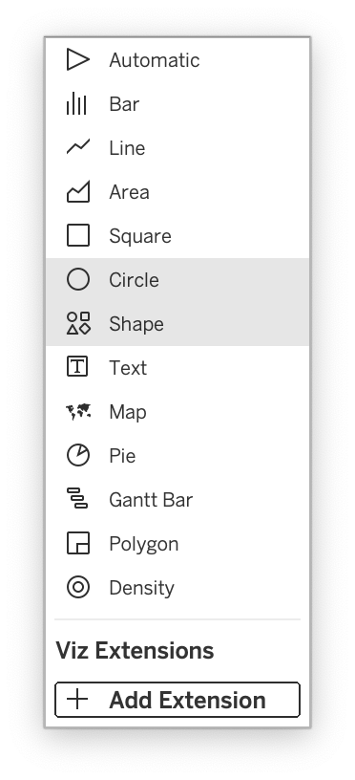

Then select Shape > More shapes, and explore the options:

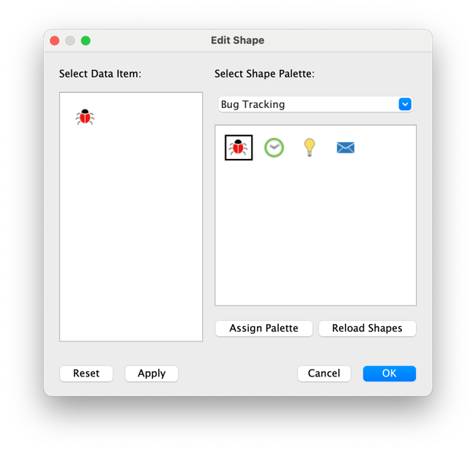

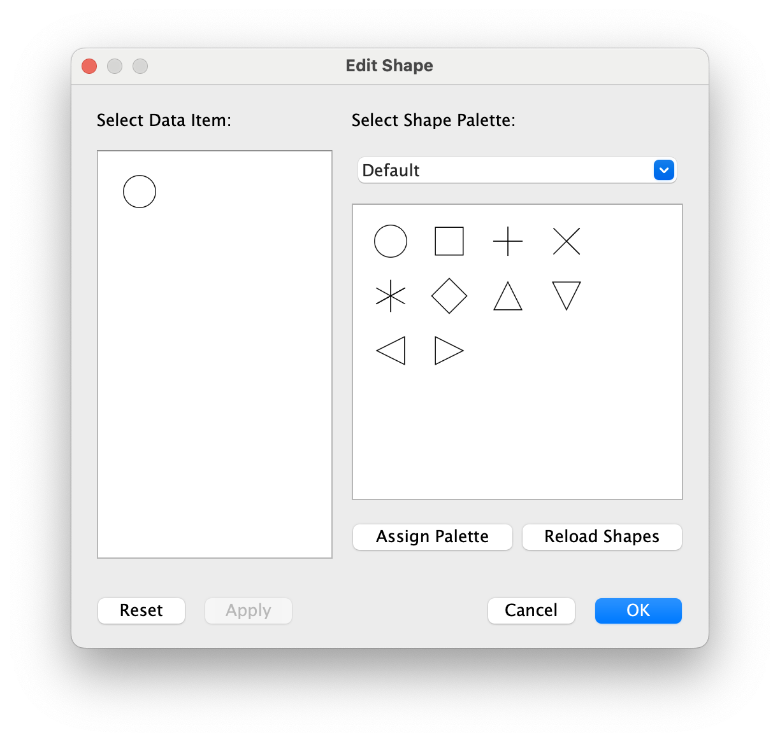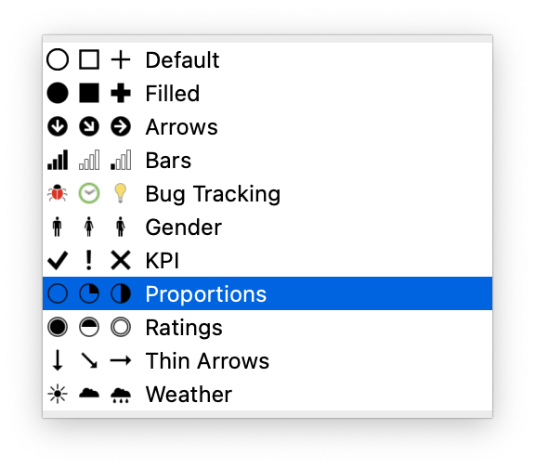

Ta-da!

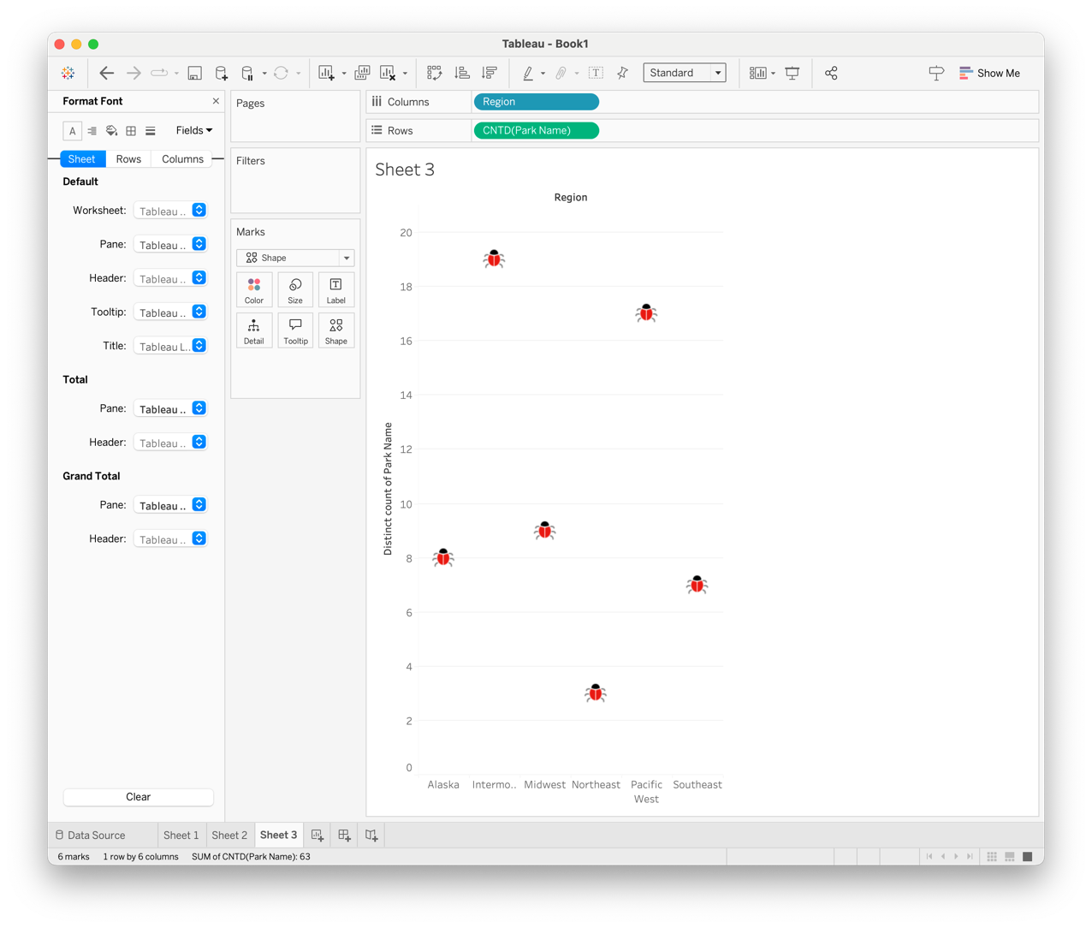

You can also add custom shapes; similar to how we added custom color palettes. Go to My Tableau Repository > Shapes. Then add a new folder and put the shapes you want in that folder. Click Reload Shapes in the shape chooser, then select your new shape!

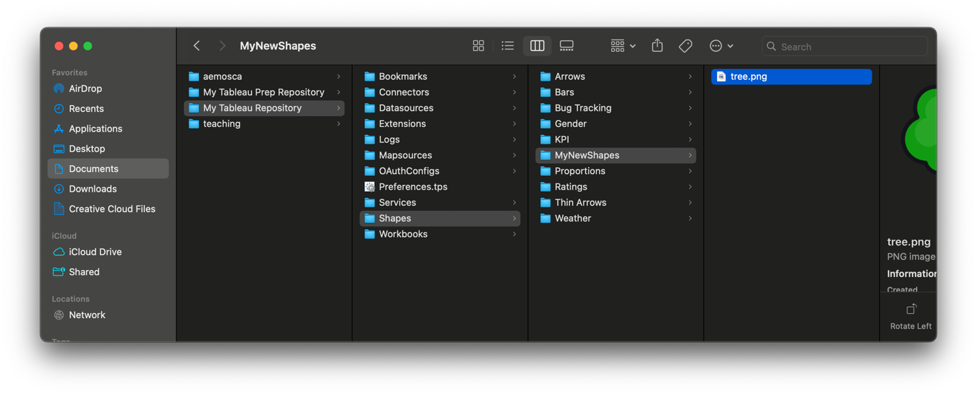

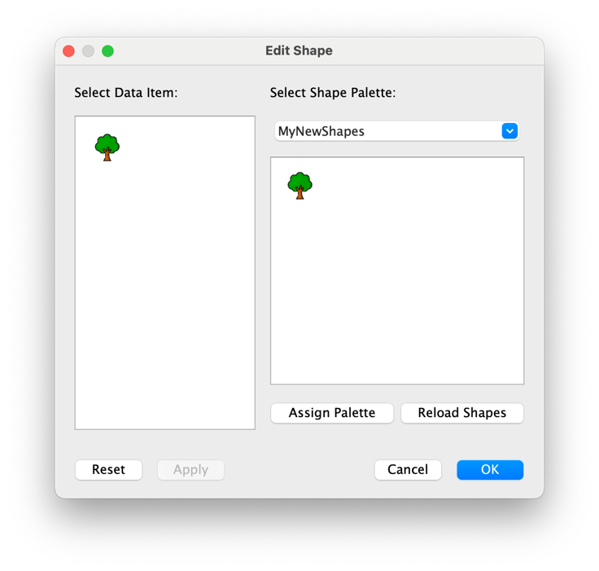

Voila!

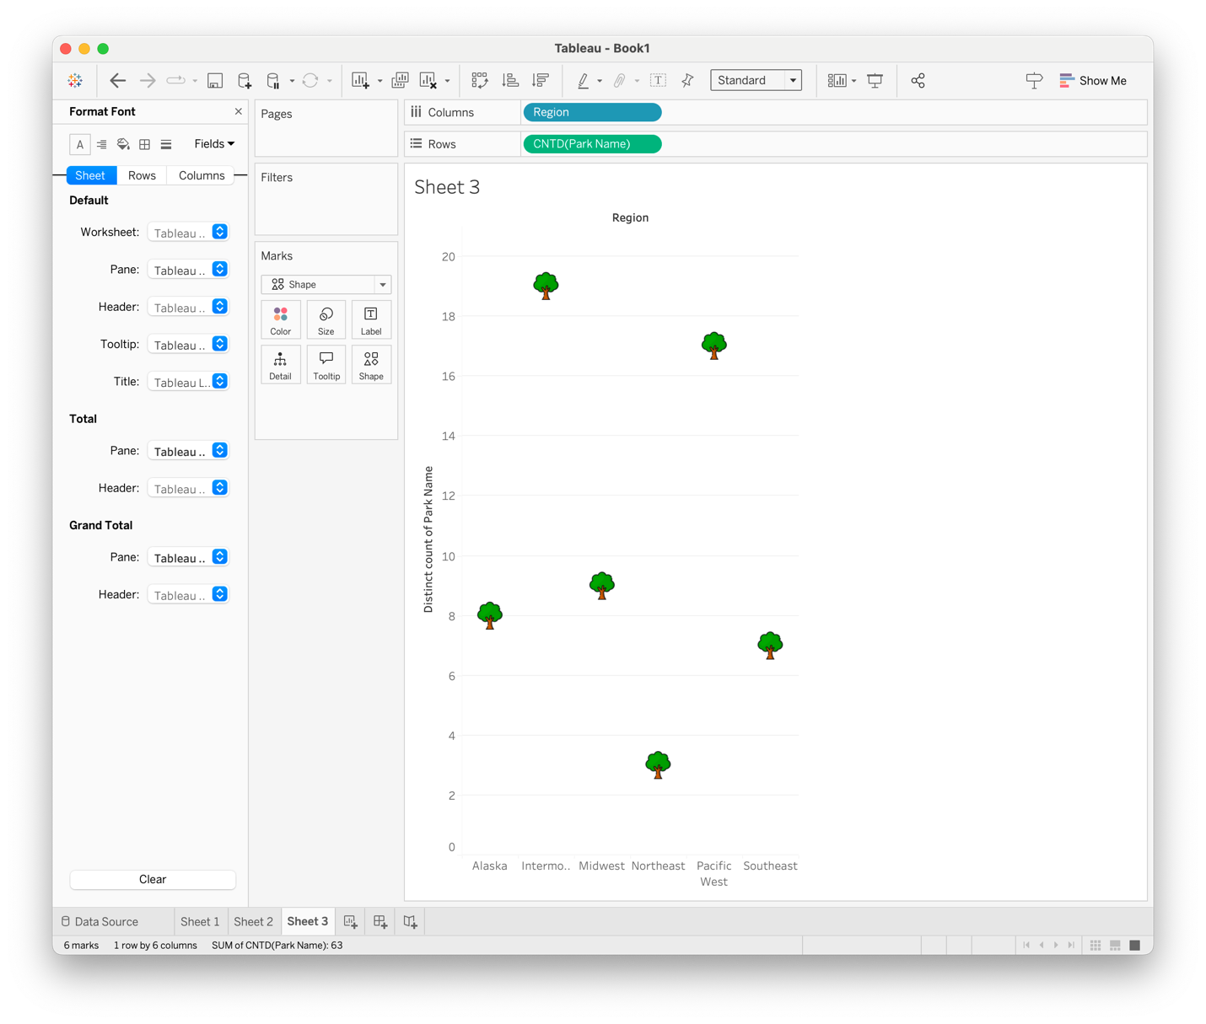

Your Turn! Use these new tools (and look up more!) to create a custom visualization with data of your choosing. At a minimum, make a visualization that uses a custom color palette, and one that uses custom shapes.